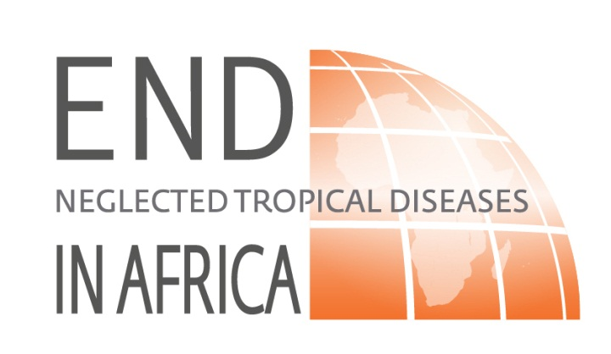
Country

FY2014

Control of Neglected Tropical Diseases

Annual Work Plan
Period Covered

Date

Submitted to:

Submitted by:

For further information, please contact:

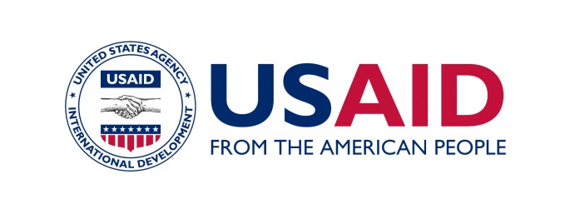
The author’s views expressed in this publication do not necessarily reflect the views of the United States Agency for International Development or the United States Government.

General Instructions for Submission.

The Annual Workplan provides FHI360, the sub-grantee and its in-country partners, USAID Washington and the in-country Mission, with an up-to-date overview of how project implementation will proceed and the information that was used to make strategic decisions. FHI360 expects that the grantees, in coordination with USAID and other partners, will undertake the following steps to prepare their Work Plan:
- Review available quantitative and qualitative data to inform program priorities and strategies.
- Create a shared vision among all program partners and strengthen partner relationships.
- Agree with the Ministry of Health (e.g. National NTD control program coordination team) program goals, objectives/results, indicators and targets.
- Determine critical project tasks and activities.
- Clarify and negotiate roles and responsibilities of implementing groups and negotiate if appropriate memoranda of understanding.

FHI360 will provide written comments to the sub-grantees within two weeks of receiving the Workplan. Following receipt of comments, the Grantee will make a brief overview presentation of the work plan and how the reviewers’ comments have been addressed. FHI360 will then approve the Workplan or request the grantee to make specific revisions. The workplan and budget will not be considered final until formal approval is granted.

Other instructions to consider:

- Workplans are due 45 days before the start of the next year for the project.
- All submissions must be in English and provided as an MSWord document of no more than 15 pages, exclusive of maps and attachments, using a bulleted and concise format in
- The Workplan should be developed in a collaborative fashion with the MOH, USAID, FHI360 and national counterparts and should clearly demonstrate how the grantee will support the national NTD program.
- All acronyms used within the text should be defined and listed alphabetically on the “Acronyms and Abbreviations” page.
- All documents included in the Workplan as Annexes should be in electronic format or digitalized in PDF.
- Workplan should be sent in electronic format to Bolivar Pou, Project Director, via email to: bpou@FHI360.0rg or uploaded to the project SharePoint site.

Table of Contents
General Instructions for Submission. 2
Acronyms and Abbreviations 4

Executive Summary 5
Background 6
Goals for the year xxxx 6
Main Activities 6
Support NTD Country Program Planning Process 6
Mapping 7
Scaling up NTD National Program 7
Mass Drug Administration 7
MDA Strategy 7
Training 8
Community Mobilization and IEC 8
Supervision 8
Supply Chain Management 9
Management of Serious Adverse Events 10
Program Monitoring and Evaluation 10
Monitoring and Evaluation of MDA 10
Program Assessments and Transition to Post-MDA Elimination Strategy 11
Sustainability issues 11
Unique country features that can affect programme performance 11
Short term Technical Assistance Request 12
Financial Management 12
Facilitate Collaboration and Coordination 12
Environmental Monitoring Plan 13
Travel Plans 13
Staffing 13
Timeline 13

Annex 1: Detailed Budget. 14
Annex 2: Annual Work plan workbook sheets. 14

Acronyms and Abbreviations

Executive Summary
This section should provide an overview of the activities that will be undertaken in the coming year organized according to the work plan. Include a brief description for each main activity (e.g. support NTDCP Planning Process, mapping, MDA, Training, Supervision, Monitoring and Evaluation, supply chain planning transition to post-MDA strategy). This section should not be longer than two pages.

Background
Briefly describe the current status of the National NTD program, other partners involved, prior year’s activities and the key results. Update the table below.
Table 1: NTD program in Country Name

Disease | Number of endemic districts (at baseline) | Number of non-endemic districts (current) |  | Number of districts needing mapping | Number of districts with ongoing MDA |  | Number of districts needing MDA, but MDA not yet started | Number of districts where MDAs have been stopped
 |  |  |  |  | USAID-funded | Others
Schistosomiasis
Soil-transmitted helminthes
Lymphatic filariasis
Onchocerciasis
Trachoma

- Summary of the activities accomplished by the project during the last year. Describe the different activities and the key results accomplished during the last year.

Goals for the year xxxx
- Describe Program goals for the year. This should reflect the Scope of Work contained in the Grant Agreement and MOH priorities for the year. Provide country program population and geographic targets for the planned MDA. Target population is defined as the population eligible for treatment, according to drug protocols.

Main Activities
List and describe how the sub grantee plans to support the (MOH) with the following essential activities:

Support NTD Country Program Planning Process
- Work with the MOH to identify/confirm the target geographic regions and populations for MDA.
- Support the MOH to conduct or update the Tool for Integrated Planning and Costing (TIPAC, previously known as FGAT) to identify gaps and unmet needs in the National NTD Program that must be addressed in order to scale-up PCT.
- Support the MOH to update the Five-year Strategic Plan (if needed). If not needed, provide update on status of document (e.g., in year 3 of 5 of 2009-2014 Strategic Plan).
- Support the MOH to develop Annual Work Plan for National NTD Program, as requested.
- Support the MOH to develop planning and micro-planning at national, regional, district and sub-district levels.
List and describe any additional activities planned to build the capacity of the National NTD Program for planning, management and implementation of the program.

Mapping
- Summarize gaps in disease mapping.
- Outline this year’s plans to complete additional disease mapping (if required). If not all mapping gaps will be met this year, mention anticipated plans for next year.

Scaling up NTD National Program
- Summarize content of most recent of treatment projection form (e.g., geographical coverage, additional number of persons to be treated, increased epidemiological and/or program coverage. State whether the treatment will be expanded to or removed from a different target population.

Mass Drug Administration

MDA Strategy
  - Describe when each activity will take place, how long MDAs are anticipated to last and how many MDA rounds are planned and which ones are founded by other donors. Also, state whether treatment for some NTDs will target sub-district level only.
  - Describe the MDA distribution strategy/platform for this year (e.g., school-based, community-based, fixed distribution point) and explain if the distribution of drugs will be done according to WHO guidelines or country protocols

Table 2. Target districts and estimated target populations for 20xx MDA
NTD | Age group targeted | Frequency of distribution | Distribution platform(s) | Number of districts | # of people Targeted
Schistosomiasis
Onchocerciasis
Lymphatic Filariasis
Soil-transmitted helminths
Trachoma

Training
- Describe USAID-supported training of new personnel required for MDA implementation, and refresher training required for previously trained personnel. Describe how the NTDCP will address supply chain management of NTD medicines during the training.

Table 3 Training Events - New Personnel and Refresher
Training Group | Topics | Number to be Trained |  |  | Number Training Days | Location of training(s)
 |  | New | Refresher | Total

MOH/MOE at Central Level

Supervisors

Supply chain managers
Drug distributors
Other (specify)

Community Mobilization and IEC
- Describe actions that will be taken to mobilize communities and how IEC materials will be disseminated prior to and during the MDA campaign.

Supervision
- Describe how the National NTD Program will be supported to conduct supervision at all levels.
- Explain how you will ensure that WHO guidelines and MOH regulations are adhered to and how monitoring mechanisms will be implemented to ensure the MDA targets are met.
- Describe actions that will help to identify and address any potential issues/bottlenecks that arise during the course of the MDAs.
- Describe actions for ensuring that data collection including completion of registries is executed according to pre-established procedures and protocols.

Supply Chain Management
- State the schedule for developing projections of need and submitting applications for each NTD medicine for the following year, and identify the source of the medicine (e.g., donation programs, through a USAID-funded mechanism, or through government procurement).
- Describe the plan for transporting NTD medicines to field distributions sites- include all levels: regional, district, and sub-district.
- Describe how lessons learned from previous MDAs will be incorporated to improve drug management (as applicable).
Complete the following table to describe how essential NTD medicine supplies will be obtained; this should match the most recent TIPAC completed in the country.
- Describe involvement of the central medical stores in the supply chain management system and the involvement of regional/district medical stores and regional/district pharmacists in SCM for NTDs. Describe how this will be addressed if it is not taking place already.

Table 4 NTD Medicines Estimated for the year XXXXXX
Drug | Source of drug ( Donation program, USAID-funded source, or government procurement)  *Indicated name of donation program, if applicable. | Quantity of drug requested | Date of Application (Month/Year) | Requested delivery date (Month/Year)
IVM

DEC

ALB

MEB

PZQ

Zithromax
syrup
Zithromax
tablet
Tetracycline eye ointment

Management of Serious Adverse Events
The MOH (often implemented through the Department of Pharmacy or Pharmacy Board), using reporting systems established by WHO and the pharmaceutical companies, should immediately report all Serious Adverse Events (SAE) for donated medicines and for medicines procured using USAID-funding. Government-established SAE reporting mechanisms should also be followed. The sub-grantee will support the MOH to implement this process.
- Describe the mechanism and actions that will be taken to ensure that SAEs are communicated to the MOH and FHI360 within 24 hours of occurrence.
- Provide Technical assistance to the MOH for monitoring and managing the SAEs, as needed.
- Set up appropriate communication channels to communicate with the affected communities and, if possible, with the media.

Program Monitoring and Evaluation

Monitoring and Evaluation of MDA
Sub-grantees in all END in Africa countries will collect the same standard indicators . End in Africa will utilize the existing M&E framework and tools developed with USAID support. FHI360 will ensure the standardized reporting forms are available to the sub-grantee.
- Outline timetable for reporting and completion of the M&E deliverables.
- Define actions for reviewing of the quality of data.
- Utilize tools for data collection that are currently in country in order to avoid duplication and additional burdens on the Government, sub-grantees and front-line data collectors.

Program Assessments and Transition to Post-MDA Elimination Strategy
Sub-grantees will report on assessment surveys and Post-MDA surveillance activities to inform on progress towards NTD elimination and/or control. Sub-grantees are entitled to the following:
- Describe in how many districts pre-TAS for LF will take place (include this information in the work plan workbook)
- Describe in how many districts TAS for LF will take place (include this information in the work plan workbook)
- Describe in how many districts trachoma impact studies will take place after 3 or 5 years of MDA (include this information in the work plan workbook M&E section)
- Describe any activity to be conducted for the assessment of onchocerciasis (if any) for the year.
- Describe any SCH and/or STH assessment to be conducted for the year.
- Describe any other M&E activities that will take place this year.
- Describe any planned efforts to work with other partners to improve the monitoring and evaluation of the NTD National Program
- Describe NGO’s plans for supporting the national strategies for sustaining NTD program achievements where MDAs have been stopped.
- List ongoing or upcoming actions to support the MOH plan for transitioning from MDA to post-MDA surveillance (LF and trachoma)

Sustainability issues
- Are NTDs included in the national surveillance system? Are NTDs reported within the HMIS? If not, how is this being addressed by the programme?
- Describe any other issues that can affect sustainability of the gains of the NTD programme and suggest ways of addressing them.

Unique country features that can affect programme performance
- Please describe unique national features such as existence of hard to reach areas, cross border issues, etc. and include ways of addressing them in the plan. If you cannot think of an answer please include in TA request.

Short term Technical Assistance Request
- List program technical constraints identified by the MOH.
- Identify the technical assistance needed to ensure proper drug management, financial management and M&E, including conducting surveys, if appropriate.

In the following table, describe the technical assistance FHI360/USAID in order of priority

Table 5 Technical Assistance Requests
Task | Technical skill required | Number of Days required

Financial Management
- Explain how you will monitor the use of USAID funds provided to support the activities detailed in this workplan to ensure that the funds are utilized in accordance with USAID regulations.
- Describe any actions that you will complete to train the MOH on the reporting requirements related to the USAID funding provided to support their activities.
- Briefly describe the financial contribution of other donors and the government, as identified in the funding gap analysis (TIPAC).

Facilitate Collaboration and Coordination
- Describe efforts to advocate for more commitment from the government and various stakeholders to increase awareness, visibility, and funding for the National NTD Program. (e.g., advocating for a specific budget line for the NTD MDA to be included in the MOH budget). Also, please state donations provided by donors other than USAID.
- Describe how the approved work plan will be disseminated to the MOH and stakeholders
- Describe how the program will engage the broader health community, for example, child health weeks and Vitamin A campaigns.
- Describe specific actions will be implemented to strengthen the NTD coordinating body under the leadership of the MOH to:
  - Improve coordination of national NTD planning, resource allocation, management and monitoring.
  - Improve coordination of donor support from domestic resources under national strategic and annual work plans.

Proposed Plans for Additional Support to National NTD Program (will be considered on a case-by case basis)
- Describe any proposed opportunities to support integration of the National NTD Program with other platforms (e.g., incorporation of NTD messages into water/sanitation programs or vice versa).
- Describe opportunities for supporting the morbidity management plans of the National NTD Program. Note: USAID will consider limited support in this area on a case-by-case basis, as funding permits.

Environmental Monitoring Plan
Describe environmental mitigation measures and monitoring activities for the year.

Travel Plans
Describe international travel plans for the next year.

Staffing
Explain team composition and changes in the project staff.

Timeline
Create a chart with major activities/timeline and milestones.

Annex 1: Detailed Budget.

Annex 2: Annual Work plan workbook sheets.

The Annual MDA Treatment Projections Form should be incorporated into this work plan as an annex.
Sentinel and spot check evaluation after 6-6 MDAs.
Contingent to fund availability and prioritization requests.

